
AMHERST - HIRED MEGAPHONES

UNPACKING & SETTING UP THE MEGAPHONE(S)

Open the box supplied carefully, so you can re-use it to send the equipment back later.

Megaphones will be supplied with one or more sets of 8 or 10 “C” or “D” size rechargeable batteries. Sometimes one set is in the megaphone already, sometimes they will need to be installed first. See later section for information on installing batteries.

USING THE MEGAPHONE(S)

The megaphone is only using battery power when either the pistol-grip “trigger” button or the detachable microphone talk button is depressed.

The volume control dial is on the right hand side of the microphone. Select the desired volume level from 0 – 10 by rotating the control.

There are basically two ways to carry and use the megaphone.

1. Microphone attached to megaphone

The megaphone may be held up in front of your mouth by holding the “pistol grip” handle. If used like this, the microphone should attached to the clip on the back of the unit. When you wish to speak, depress the “trigger” button on the pistol grip handle and speak into the microphone.

2. Microphone detached from megaphone(not all megaphones have detachable mics)

Detach the microphone by sliding it upwards – please do not pull it away from the megaphone or you might snap the clip off. Use the shoulder strap provided to take the weight of the megaphone. Use the microphone detached from the unit, pressing the “talk” button on the left hand side of the microphone when you wish to speak.

You can lock the talk button by pushing it and then sliding it upwards. If you do this, please remember to unlock it when you have finished speaking, or you will rapidly discharge the batteries.

You must hold the microphone very close to your lips or it won’t pick up your voice.

ALERT SIREN

The megaphone is equipped with a built-in siren, which is useful for attracting the attention of your audience before you begin speaking. It can be especially useful in an emergency situation, such as announcing that people need to move, clear an area, or to evacuate somewhere etc. To use the siren, move the siren switch on the left side of the megaphone to “ON”. To stop the siren sounding, move the siren switch to “OFF”.

Warning: the siren is VERY LOUD! Use with caution…….

INSERTING OR CHANGING THE BATTERIES

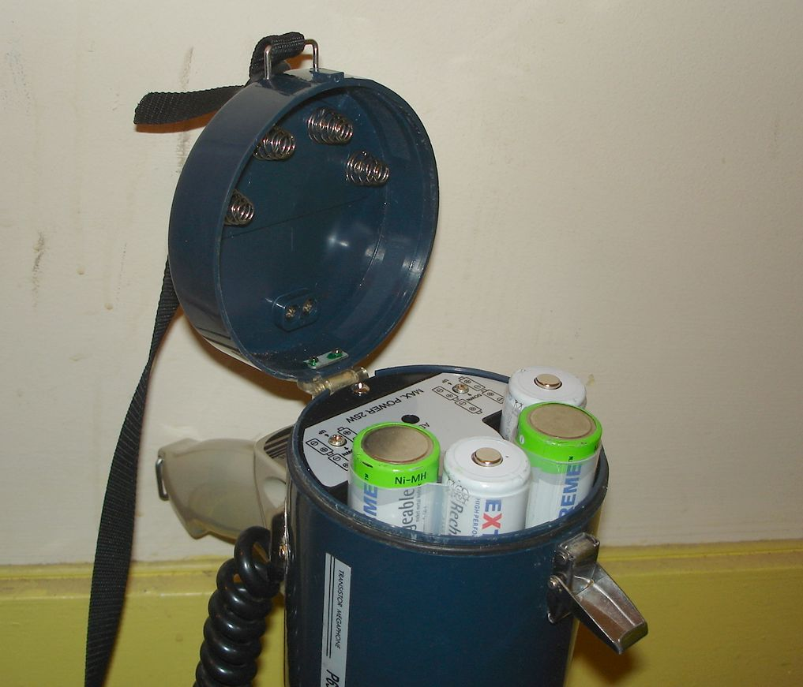
To install or swap over the batteries, place the megaphone “horn down” on a table, then undo the “hasp” catch and swing the end open on its hinge. The batteries are usually inside plastic tubes to make swapping them easier.

Lift the tubes out, and empty the flat batteries if any. Then, place the new batteries into the tubes following the polarity diagram printed into the sides of the plastic tubes. Then place the two tubes full of batteries back into the megaphone, making sure you get the polarity (+ and -) the right way round – if you look into the battery compartment you can see + and – marked at the bottom in the plastic.

Then close the battery door and latch the hasp closed – sometimes you have to hold down the battery door against spring pressure while you fasten the hasp.

The megaphone is now ready for use.

If it doesn’t work after putting in new batteries – double-check that all the batteries are inserted the right way round – follow the diagrams on the battery tubes and on the megaphone itself.

Please do not throw out the flat rechargeable batteries. They are quite expensive - £4 + VAT for each battery, and we need them all back!

RETURNING THE MEGAPHONE(S)

Pack the unit away in its box, including any rechargeable batteries that you may have removed, and this instruction sheet, and send it all back to us at:

Amherst Enterprises Limited
70 Kingsgate Road
LONDON NW6 4TE Tel: 020 7328 9792

Please use a “trackable” or “signed-for” delivery service with appropriate insurance, it is your responsibility until we get it back here.

The megaphone is your responsibility until we get it back to our office. If you accidentally dropped it/damaged it, or had other problems with it, please let us know what has happened.

